Creating a New Old Sturbridge Village Membership Account

Learn how to register a new account on the Old Sturbridge Village ticket portal to manage your membership access. This guide provides a simple walkthrough of the verification process to help you get logged in quickly and securely.

Account Registration
- Navigate to https://osv.ticketapp.org/portal/pages/tickets

- Open the My Account menu.
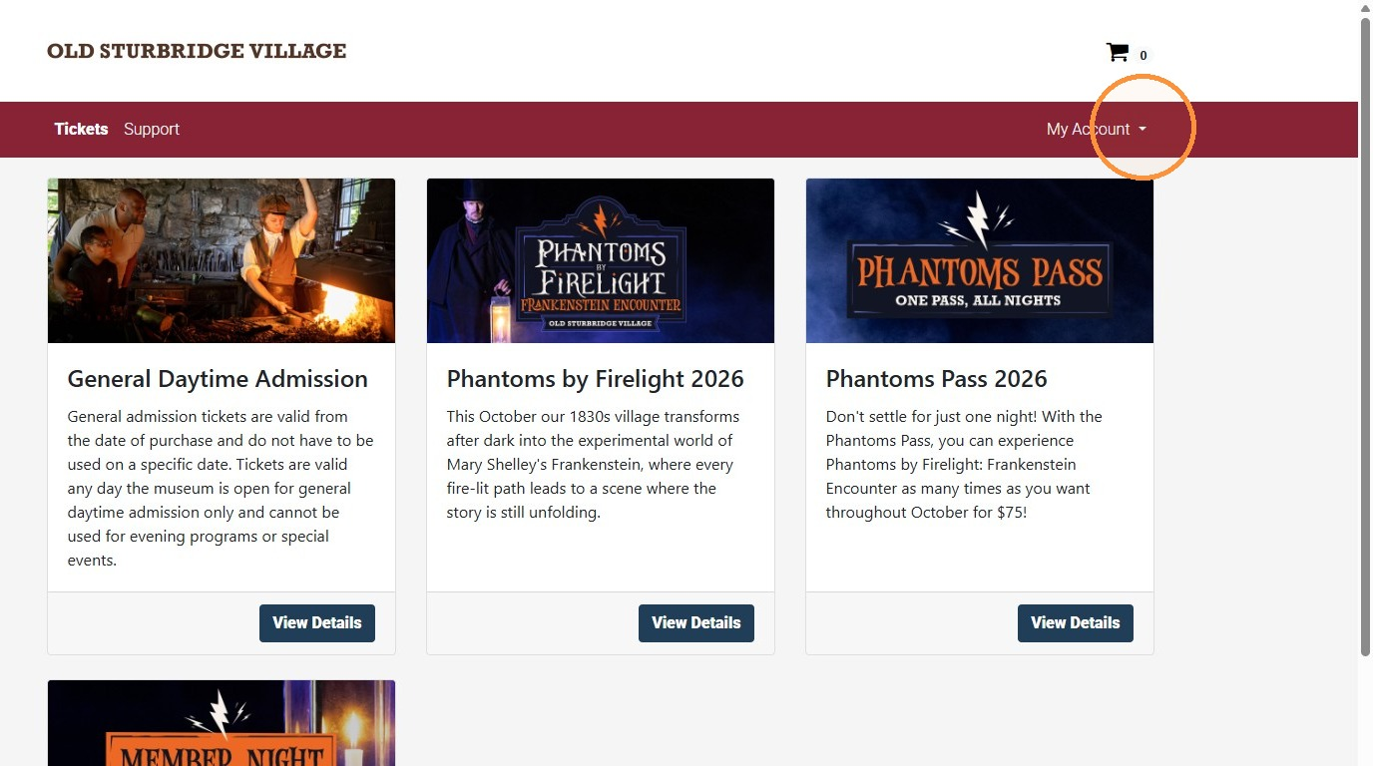
- In the dropdown menu, select Create Account.
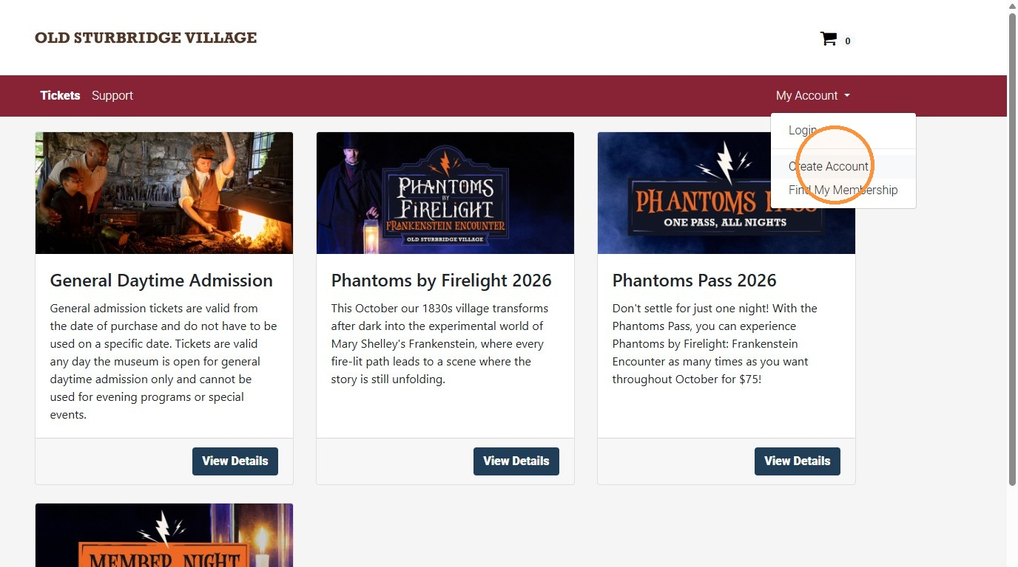
- Enter your first and last name.
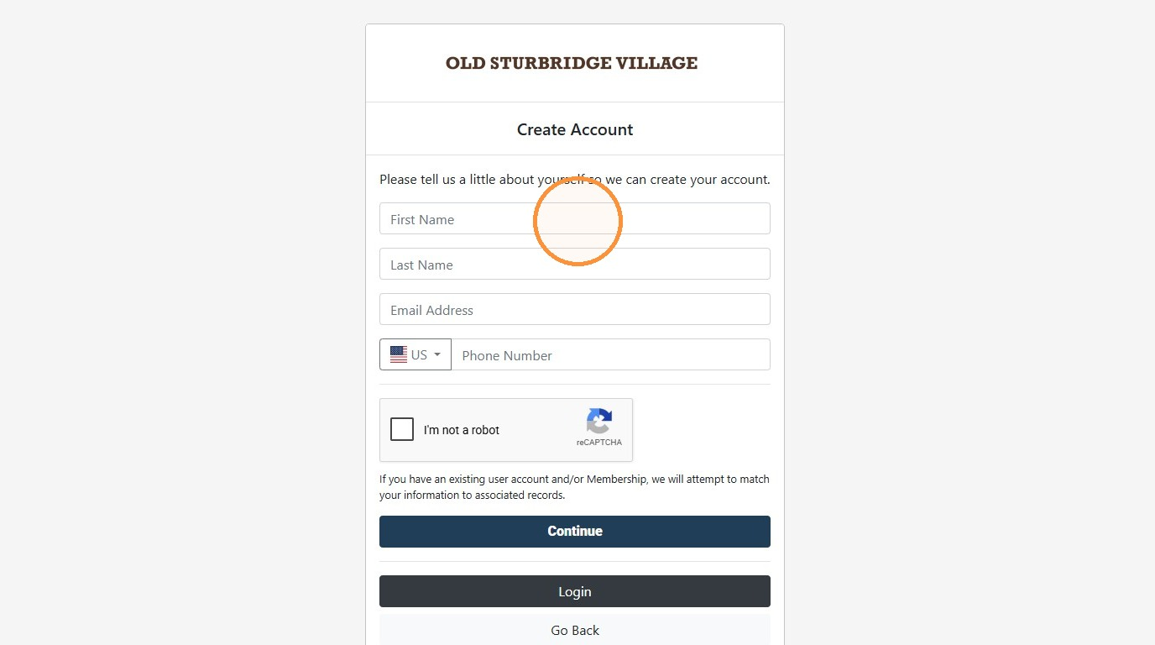
- Enter your email address.
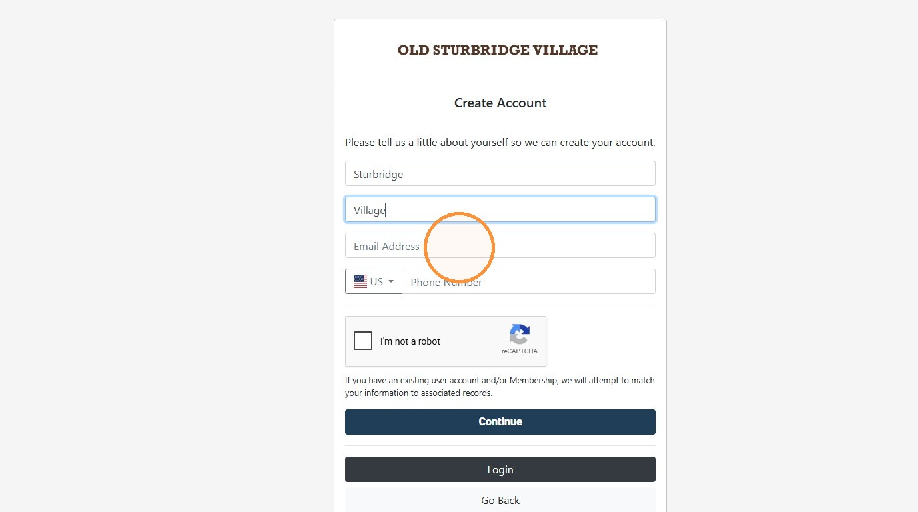
- Enter your phone number. Note if it is a cell phone, you can receive text messages.
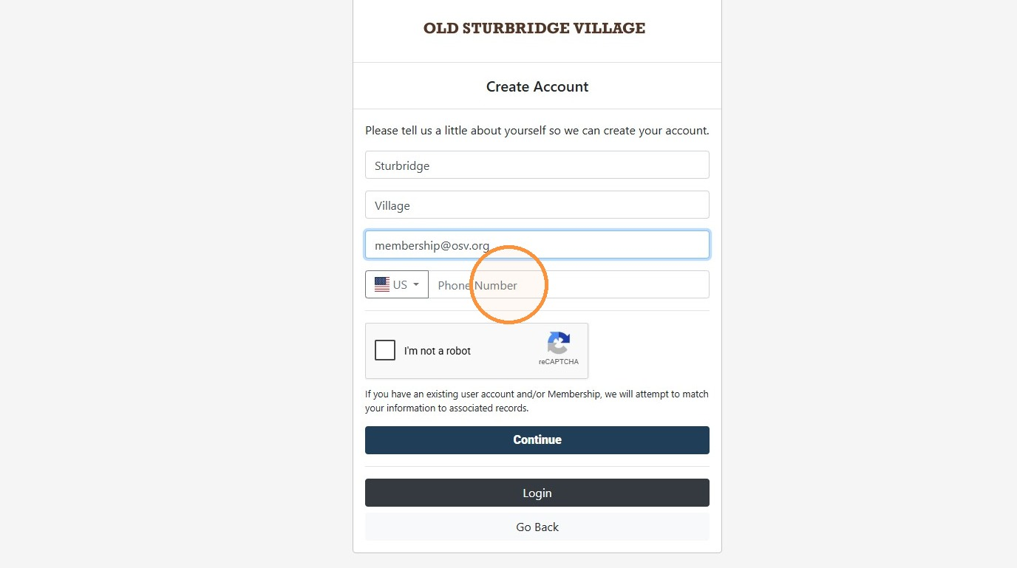

Verification Setup
- Check off the “I'm not a robot” reCAPTCHA.
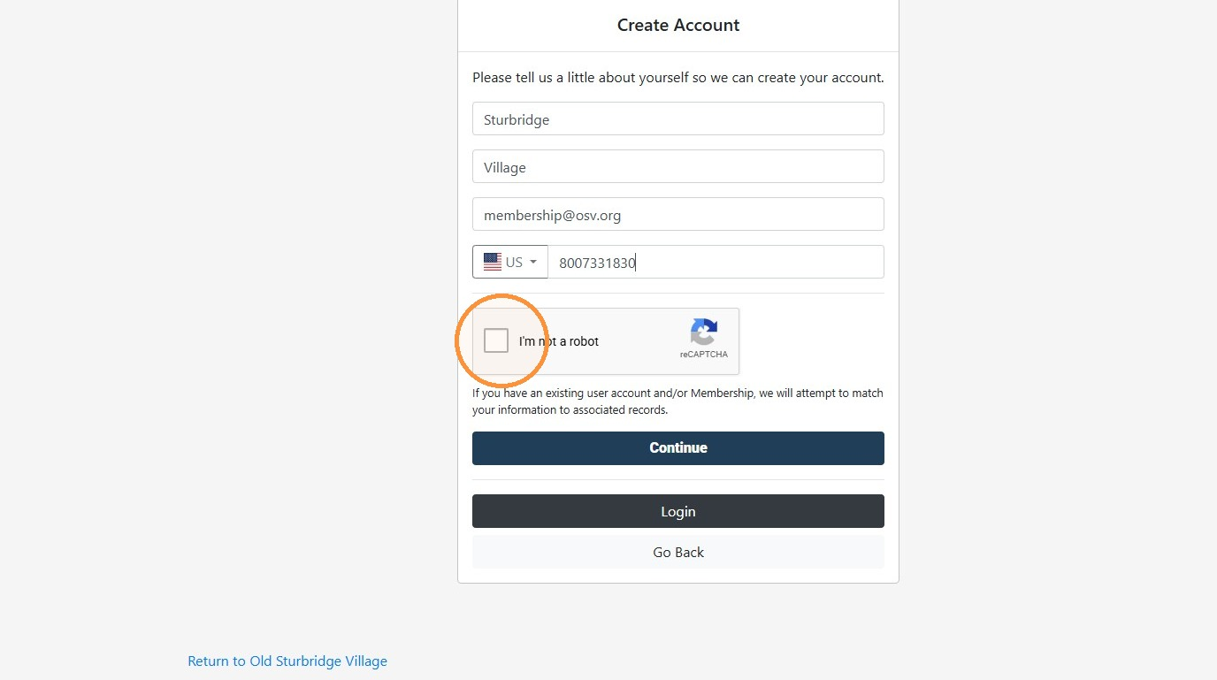
- Click "Continue"
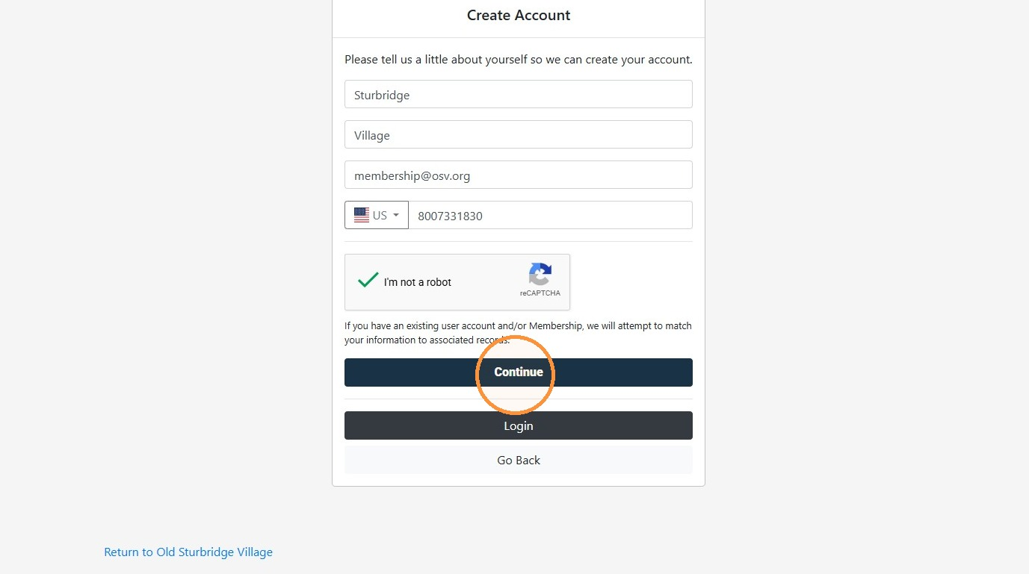
- Select your preferred verification option.
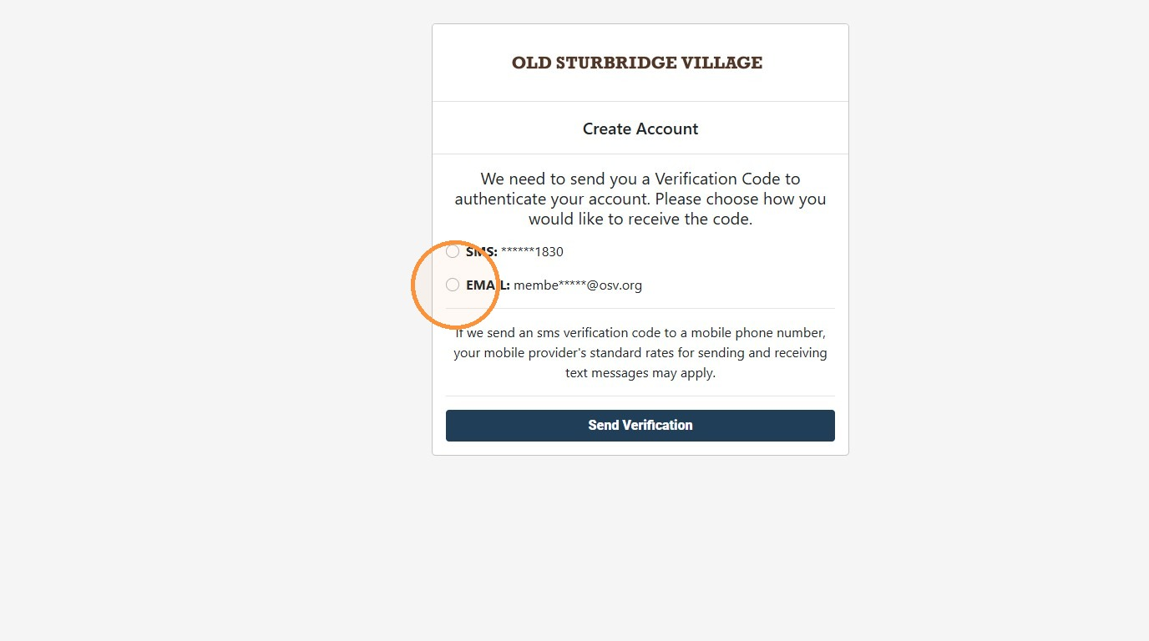
- Click "Send Verification." Then check your email address or cell phone for the verification code.
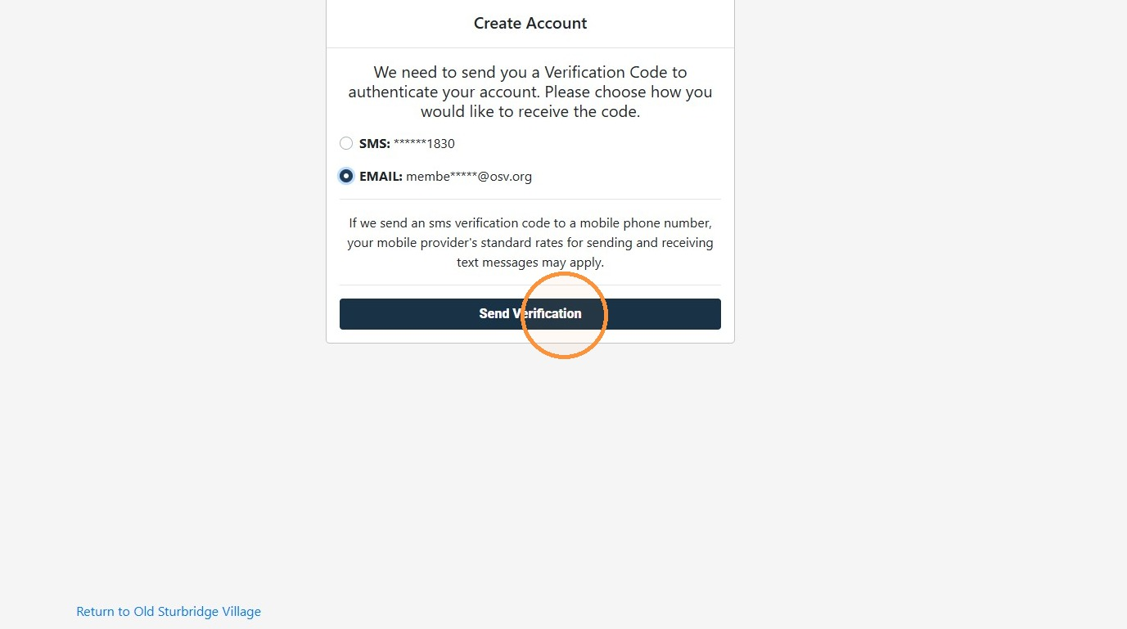

Email Verification
- Enter and submit the verification code that was sent to either your email address or cell phone.
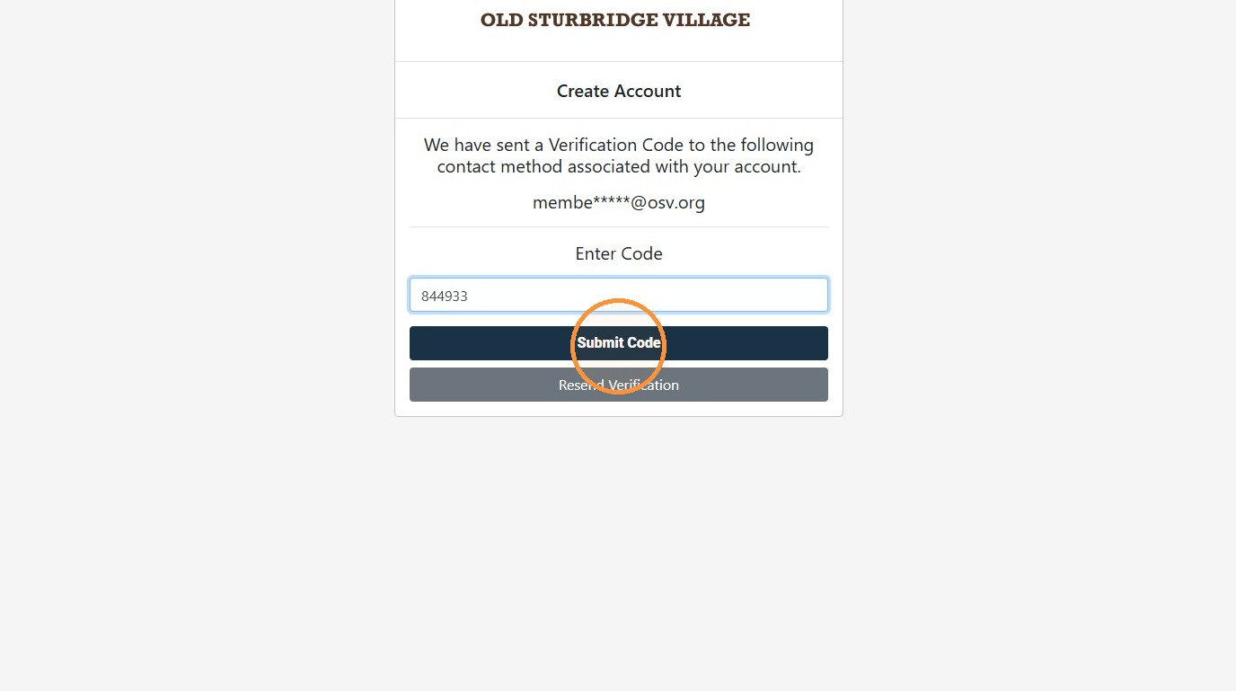

Password Creation
- Create a Password and enter it into both fields.
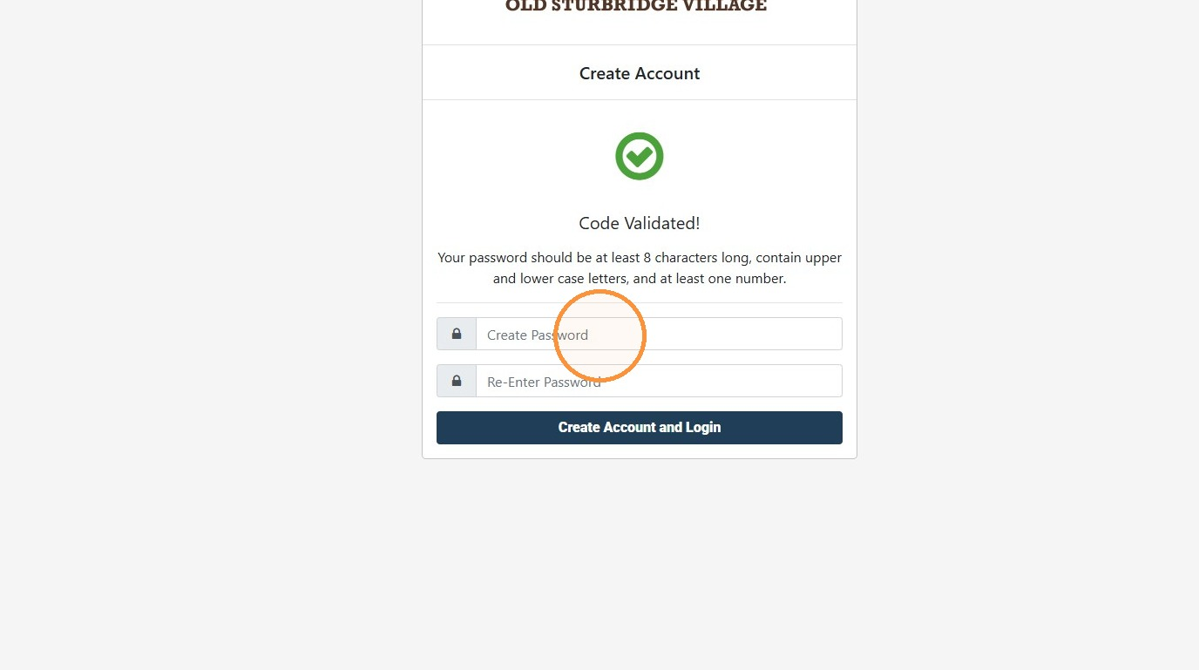
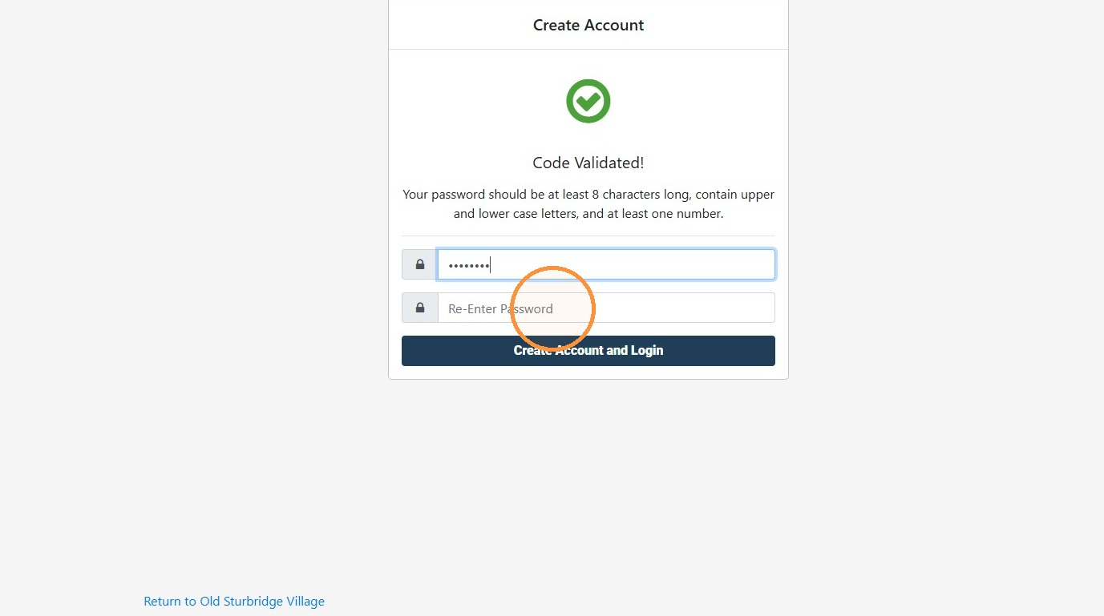
- Click "Create Account and Login."
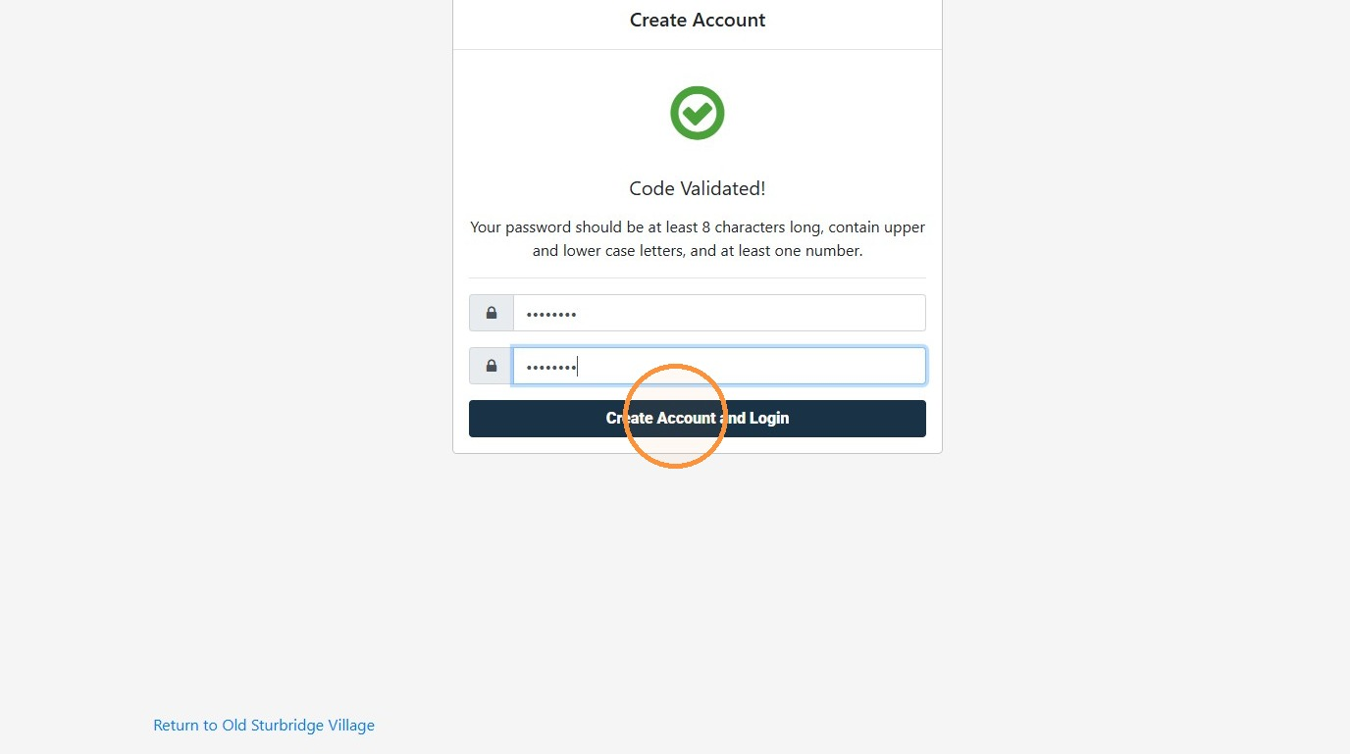
- Click "Done." Congratulations, you have created an account!
